Name: Pranali Sonawane
Subject: CCNA
Date: 19-11-2025
Lab 27– : ACLs on two routers using Standard ACL and Extended ACL.
First, take two routers (for example, 1841 models), two switches, and four PCs.Connect the routers, switches, and PCs using straight-through cables.Use a crossover cable to connect the FastEthernet interfaces between the two routers.

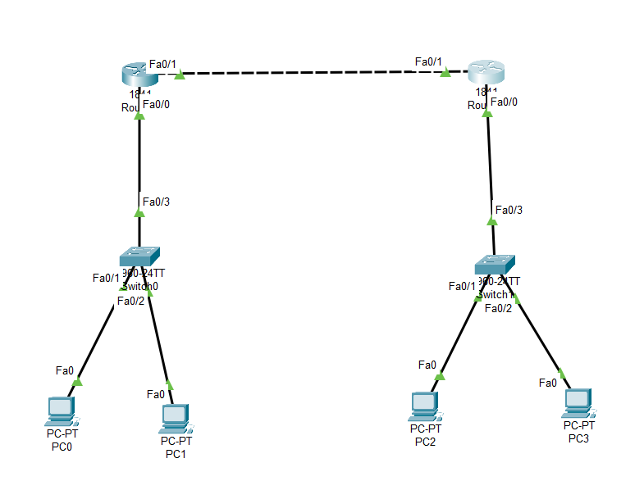
Open Router 0 – CLI prompt then type following commands
Router>enable
Router#configure terminal
Router(config)# interface fastEthernet 0/0
Router(config-if)# ip address 10.0.0.1 255.0.0.0
Router(config-if)#no shutdown
Router(config-if)#exit

Router(config)#interface fa0/1
Router(config-if)#ip address 30.0.0.1 255.0.0.0
Router(config-if)#no shutdown
Router(config-if)#exit

Router(config)# router ospf 1
Router(config-router)# network 10.0.0.0 0.255.255.255 area 0
Router(config-router)# network 30.0.0.0 0.255.255.255 area 0
Router(config-router)# exit
Router#show ip route
Router#show ip os nei

Router 0 - Standard ACL
Router>enable
Router#configure terminal
Router(config)#access-list 1 deny 10.0.0.0 0.255.255.255
Router(config)# interface fastEthernet 0/0
Router(config-if)# ip access-group 1 in (Ping is not Working )
Router(config-if)# no ip access-group 1 in (Ping is working )

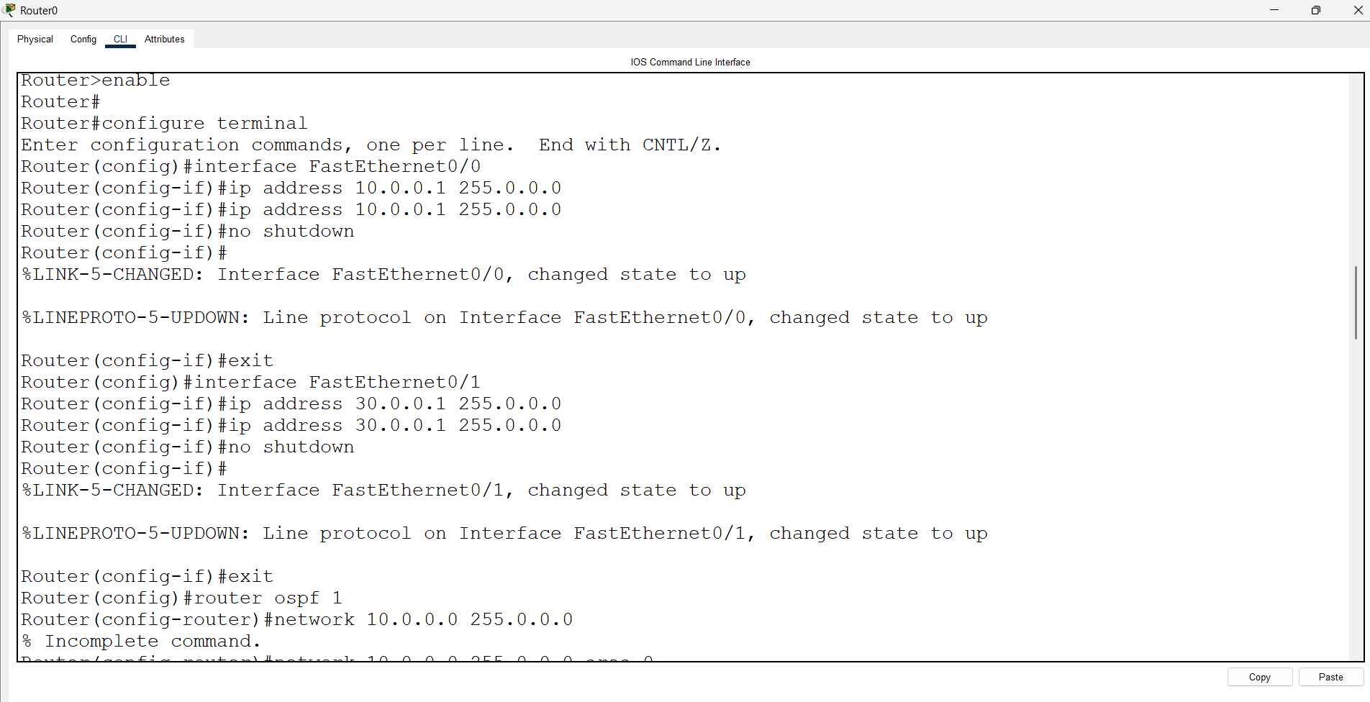

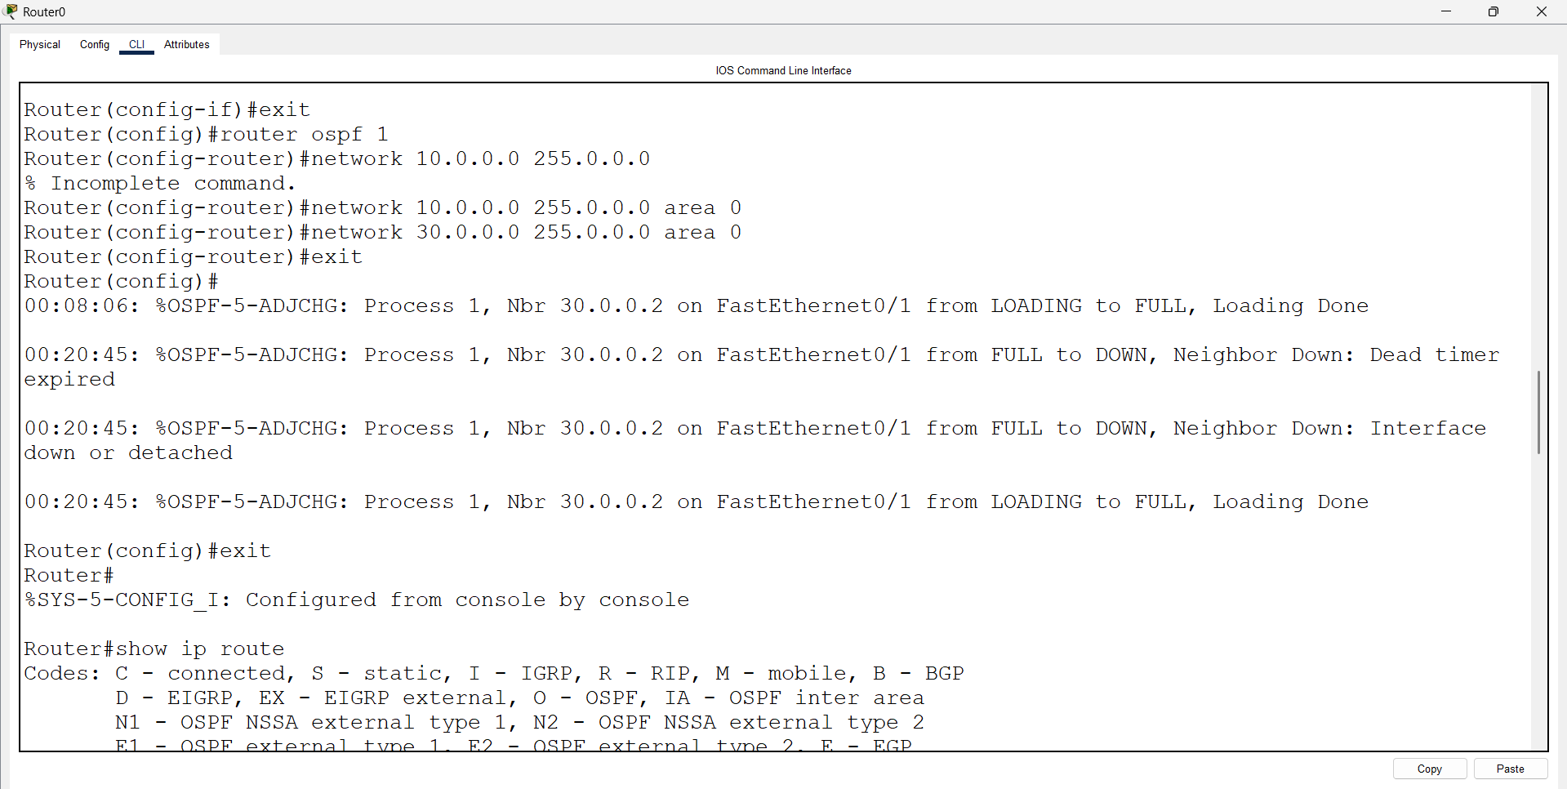

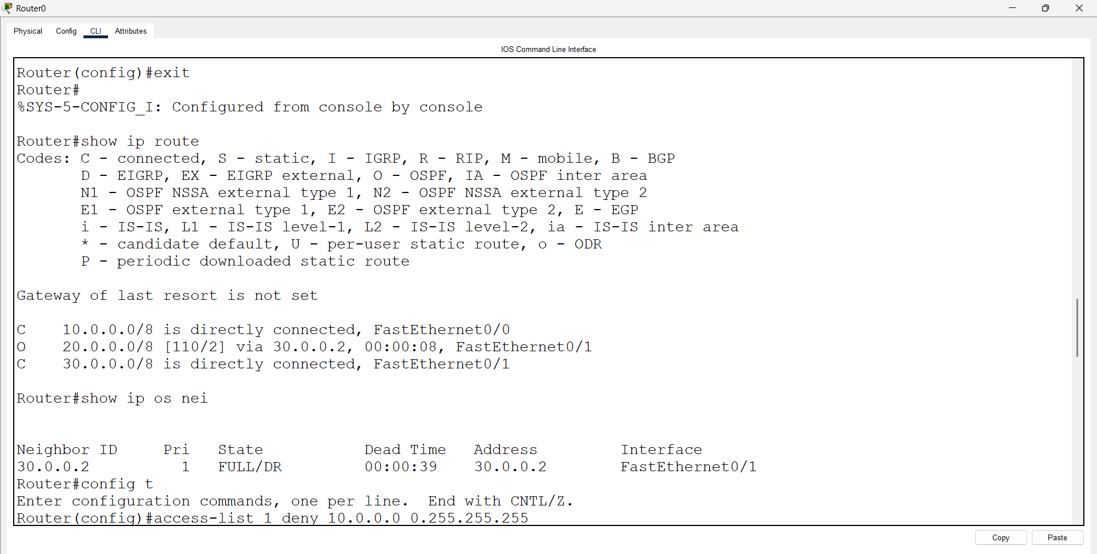

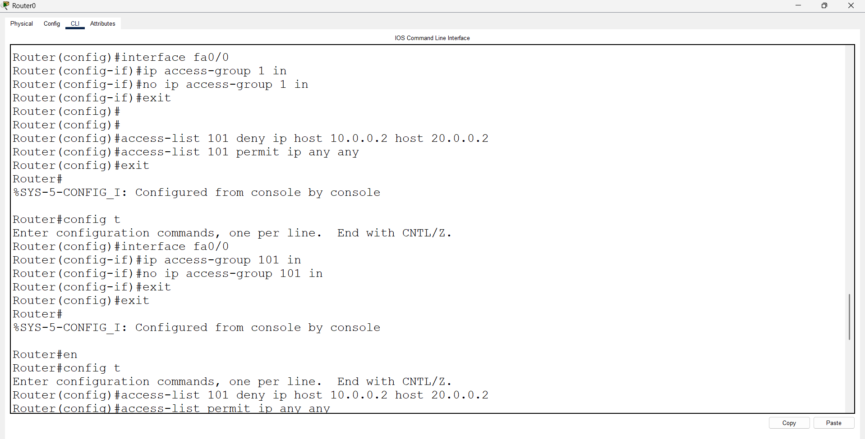

Open Router 1 – CLI prompt then type following commands
Router>enable
Router#configure terminal
Router(config)# interface fastEthernet 0/0
Router(config-if)# ip address 20.0.0.1 255.0.0.0
Router(config-if)#no shutdown
Router(config-if)#exit

Router(config)#interface fa0/1
Router(config-if)#ip address 30.0.0.2 255.0.0.0
Router(config-if)#no shutdown
Router(config-if)#exit

Router(config)# router ospf 1
Router(config-router)# network 20.0.0.0 0.255.255.255 area 0
Router(config-router)# network 30.0.0.0 0.255.255.255 area 0
Router(config-router)# exit
Router#show ip route
Router#show ip os nei

Router 0 - Standard ACL
Router>enable
Router#configure terminal
Router(config)#access-list 2 deny 20.0.0.0 0.255.255.255
Router(config)# interface fastEthernet 0/0
Router(config-if)# ip access-group 2 in
Router(config-if)# no ip access-group 2 in
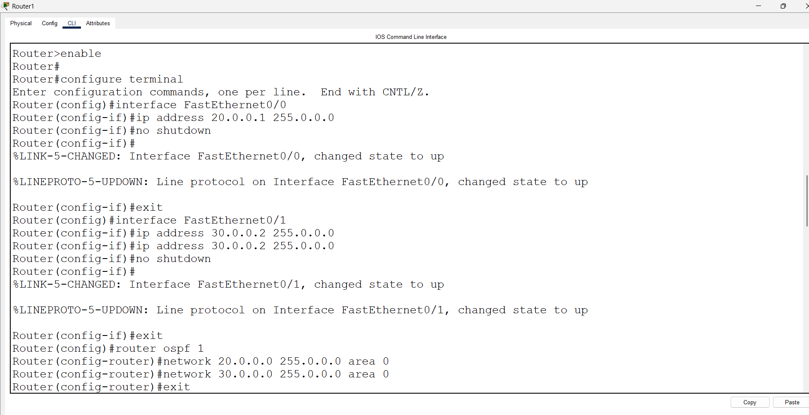

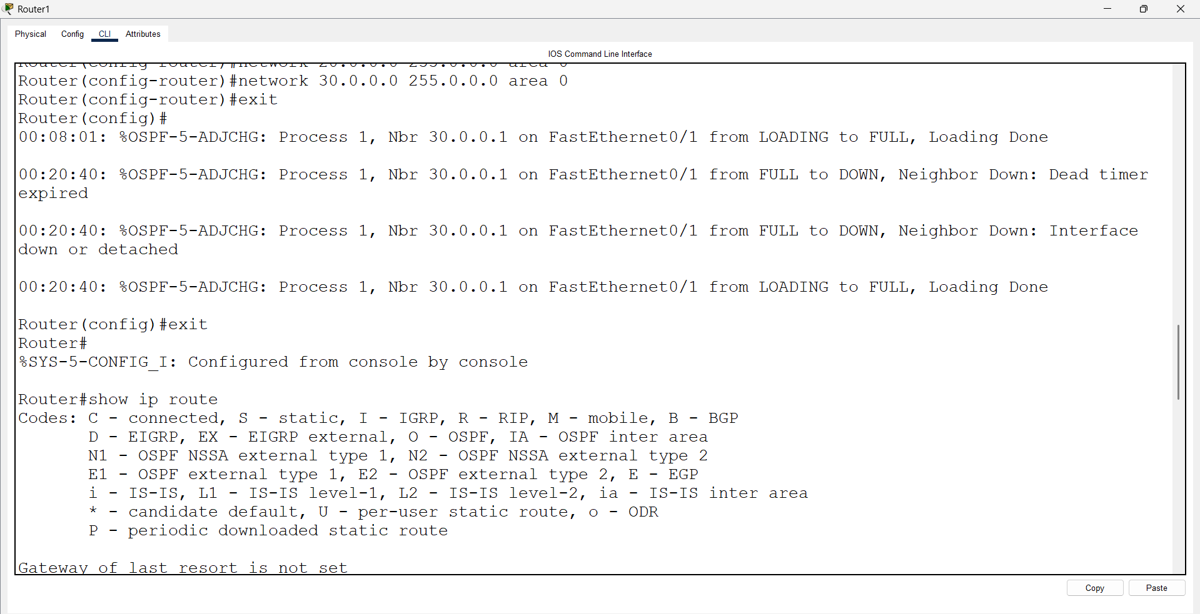

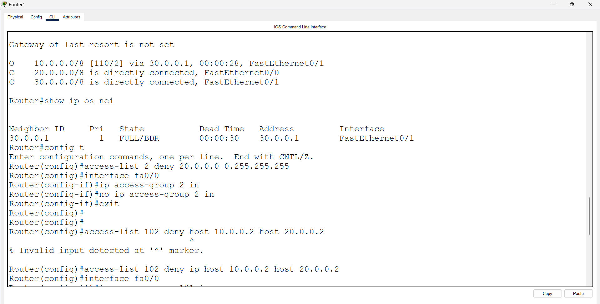

Router 0 - Extended ACL:
Router>enable
Router#configure terminal
Router(config)#access-list 101 deny ip host 10.0.0.2 host 20.0.0.2
Router(config)#access-list 101 permit ip any any
Router(config)# interface fastEthernet 0/0
Router(config-if)# ip access-group 101 in
Router(config-if)# no ip access-group 101 in

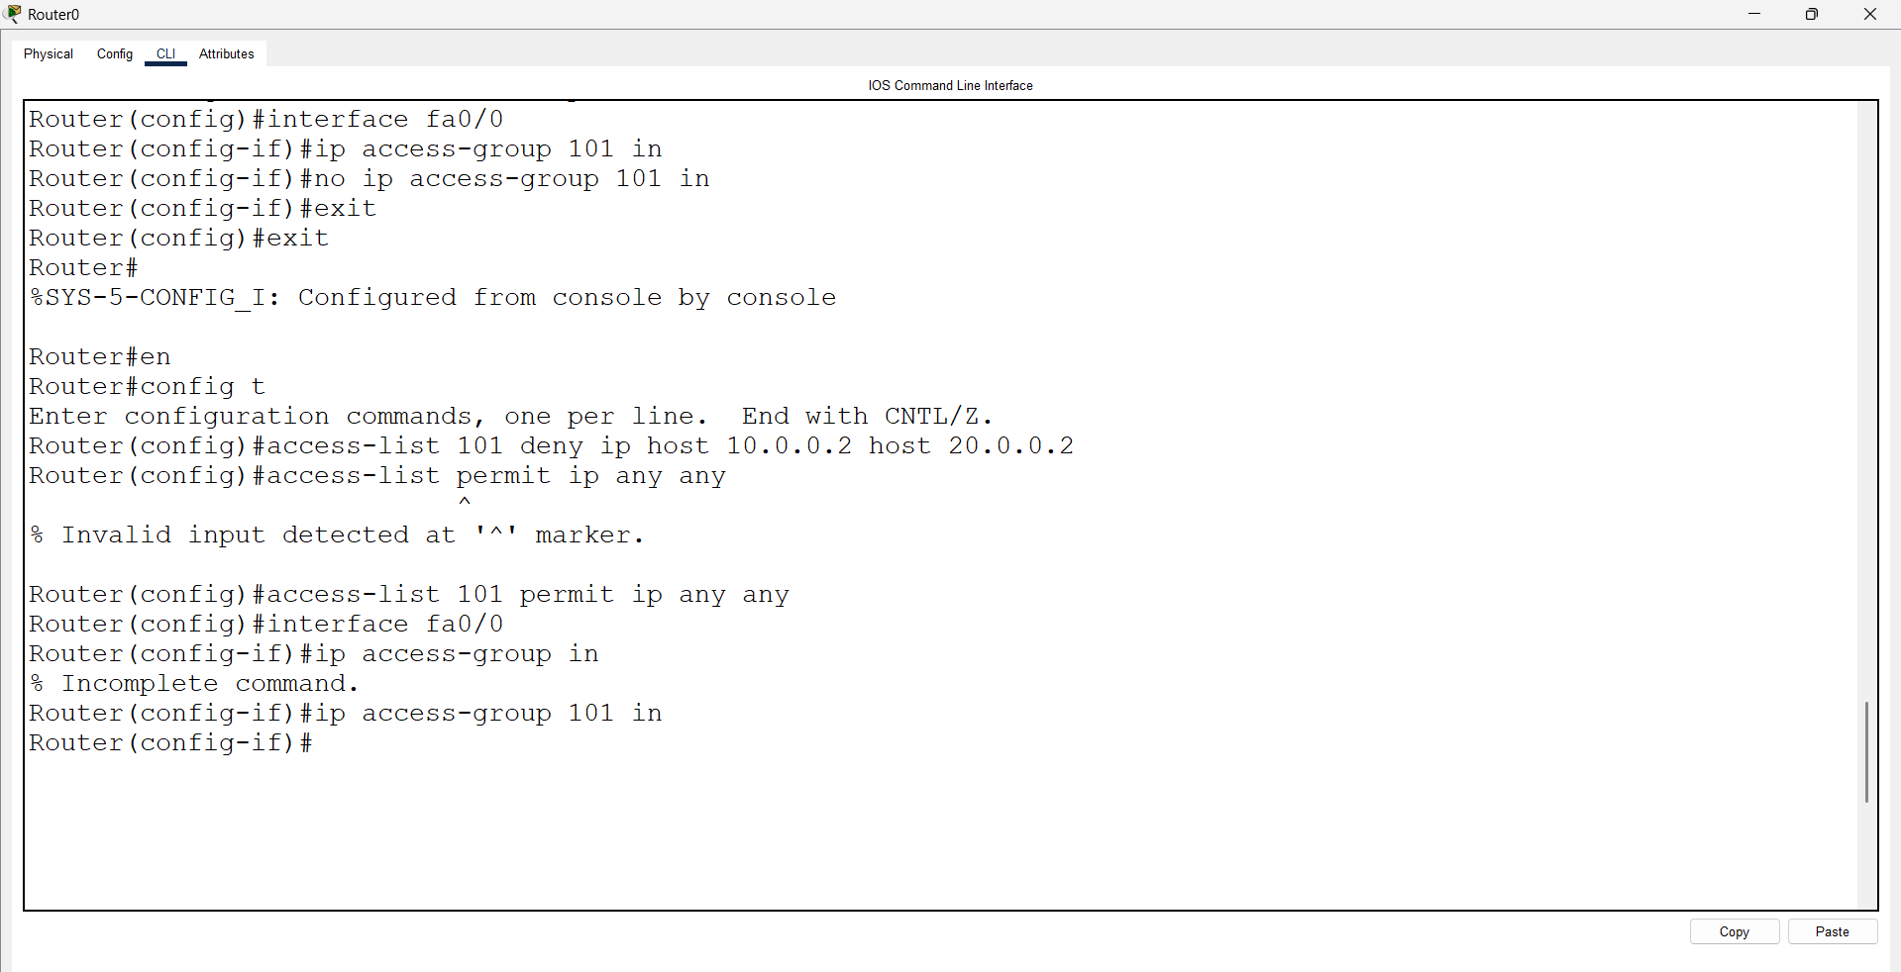

Self Study:
Router 1 - Extended ACL:
Router>en
Router#config t
Enter configuration commands, one per line. End with CNTL/Z.
Router(config)#access-list 102 deny ip host 20.0.0.2 host 10.0.0.2
Router(config)#access-list 102 permit ip any any
Router(config)#interface fa0/0
Router(config-if)#ip access-group 102 in
Router(config-if)#no ip access-group 102 in

